RefectoCil Intense Brow[n]s Kit

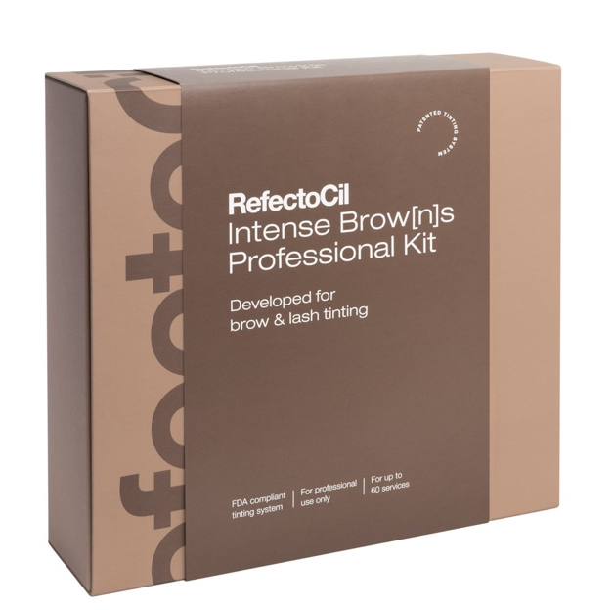
Everything needed in one professional Kit!

The RefectoCil Intense Brow[n]s Kit contains everything needed to complete the premium Brow Intensifying ServiceTM.
The FDA compliant products are ideally developed for eyebrows - and lash tinting. For fuller looking eyebrows and expressive eyelashes.

Contents:

1x Micellar Eye Make-up Remover (5.07 US fl.oz)
2x Intense Brow[n]s Intensifying Primer Medium (0.5 US fl.oz)
2x Intense Brow[n]s Intensifying Primer Strong (0.5 US fl.oz)
4x Intense Brow[n]s Base Gels – ash brown, chocolate brown, deep brown, black brown (0.5 US fl.oz)
4x Intense Brow[n]s Activator Gel (0.5 US fl.oz)
1x Intense Brow[n]s Tint Remover (5.07 US fl.oz)
1x Browista Toolkit
1x Brow Mapper
3x Eye Care Pads

Application:

• Lash Tinting: Attach RefectoCil Silicone Pads or RefectoCil Eye protection papers with
RefectoCil Skin Protection Cream & Eye Mask
• Optionally apply RefectoCil Intense Brow[n]s Intensifying Primer in Strong or Medium only to
the eyebrows– leave on for 4 minutes and remove with dry Q-tip
• Apply Intense Brow[n]s Base Gel – leave on for 2 minutes and remove with dry Q-tip
• Apply Intense Brow[n]s Activator Gel – leave on for 1 minute and remove with moist cotton
ball - done!
Additional information:
• Please only use the Intensifying Primer for eyebrow tinting!
• Please don’t mix Intensifying Primer, Base Gel and Activator Gel!
Logistic data:
Item number | Sales unit  EAN & measurements | Order unit  EAN & measurements | Transport unit | Customs tariff number
05072 | 9 003877 906001  Measurements (cm):  23l x 21,6w x 6,2h  Content: see above  Single weight: 0,899 kg | X  Content: 1 kit  Weight: 0,899 kg | Measurements (cm):  45,5 x 23,0 x 35,0  Content: 10 kits  Weight: 9,4 kg | 33079000

